**Higher Order Functions and Passing Functions as Arguments**

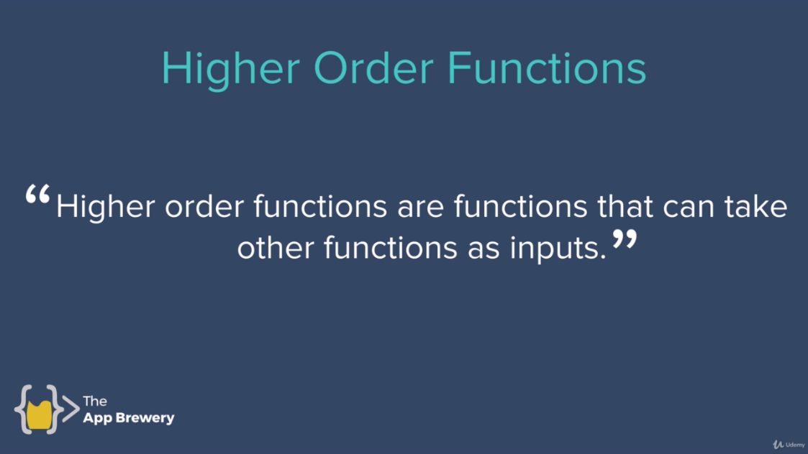

And this feature is available in number of modern languages like **JavaScript, Java, Ruby, Python, Haskell, C++, PHP, C#, Go, Swift etc.** It’s not universal means not available in all programming languages but in a number of programming languages on which **JavaScript** is rely on.

**Example:**

function add(num1, num2){

return num1+num2;

}

function subtract(num1, num2){

return num1-num2;

}

function multiply(num1, num2){

return num1*num2;

}

function division(num1, num2){

return num1/num2;

}

function calculator(num1, num2, operator){

return operator(num1, num2);

}

//Let's add debugger and see every step of how code runs

debugger(3,4,multiply);

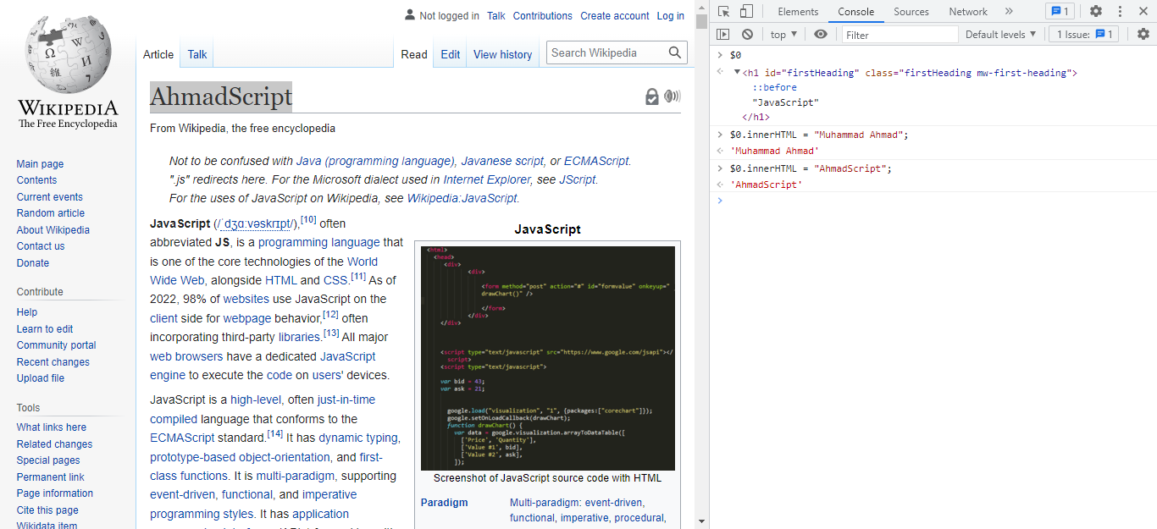

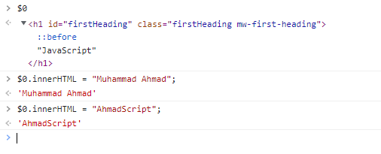

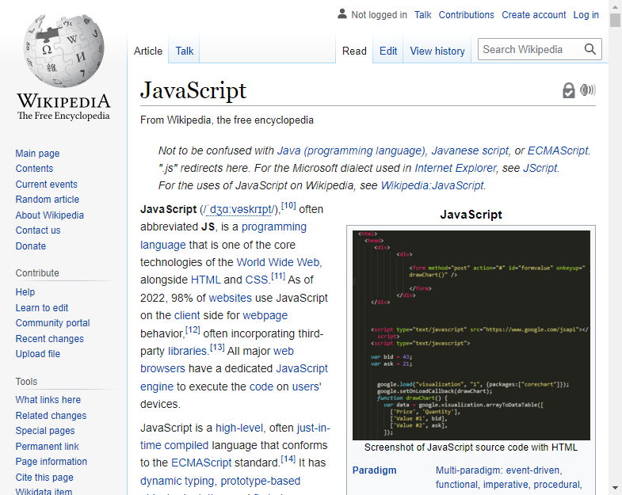

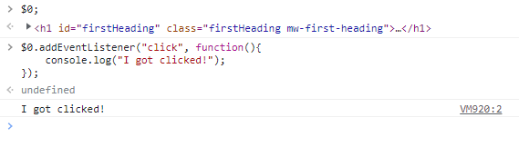

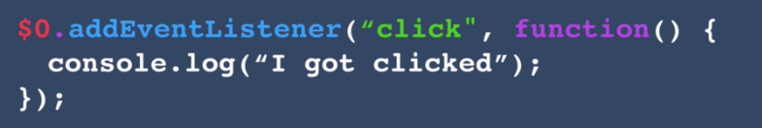

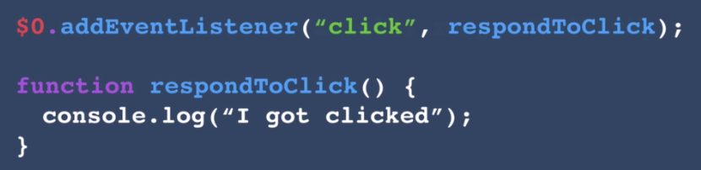

First input is input1 and second input is the function that we should be called once h1 detect to click event.

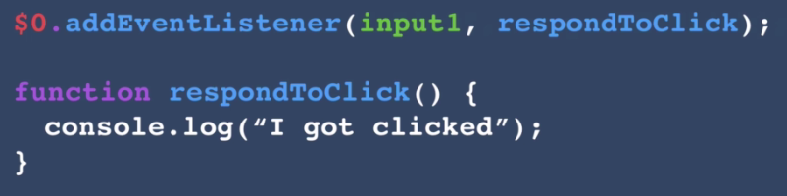

Input1 specifies what event it should specify and input2 specifies that what should it do that’s it’s once detected. And it’s different from above functions.

